**Assignment - 08**

Question No – 01

#include <stdio.h>

#include <stdlib.h>

#include <string.h>

#include <dirent.h>

#include <sys/stat.h>

#include <pwd.h>

typedef struct {

char username[256];

off_t filesize;

} FileInfo;

FileInfo *fileInfos = NULL;

size_t fileCount = 0;

// Function to add file information

void addFileInfo(const char *username, off_t filesize) {

fileInfos = realloc(fileInfos, (fileCount + 1) * sizeof(FileInfo));

if (fileInfos == NULL) {

perror("Failed to allocate memory");

exit(EXIT_FAILURE);

}

strcpy(fileInfos[fileCount].username, username);

fileInfos[fileCount].filesize = filesize;

fileCount++;

}

// Map function: Collect file sizes and owners

void mapFiles() {

DIR *dir;

struct dirent *entry;

struct stat fileStat;

struct passwd *pw;

dir = opendir(".");

if (dir == NULL) {

perror("Failed to open directory");

exit(EXIT_FAILURE);

}

while ((entry = readdir(dir)) != NULL) {

if (entry->d_type == DT_REG) { // Only regular files

if (stat(entry->d_name, &fileStat) == 0) {

pw = getpwuid(fileStat.st_uid);

if (pw != NULL) {

addFileInfo(pw->pw_name, fileStat.st_size);

}

}

}

}

closedir(dir);

}

// Reduce function: Find maximum size and corresponding users

void reduceFiles() {

off_t maxSize = 0;

char *users = NULL;

for (size_t i = 0; i < fileCount; i++) {

if (fileInfos[i].filesize > maxSize) {

maxSize = fileInfos[i].filesize;

free(users);

users = strdup(fileInfos[i].username);

} else if (fileInfos[i].filesize == maxSize) {

// Add user to the list if not already there

if (strstr(users, fileInfos[i].username) == NULL) {

char *newUsers = malloc(strlen(users) + strlen(fileInfos[i].username) + 2);

if (newUsers == NULL) {

perror("Failed to allocate memory");

exit(EXIT_FAILURE);

}

sprintf(newUsers, "%s,%s", users, fileInfos[i].username);

free(users);

users = newUsers;

}

}

}

if (maxSize > 0) {

printf("Maximum file size: %ld bytes\n", maxSize);

printf("Users owning the largest file: %s\n", users);

} else {

printf("No files found.\n");

}

free(users);

}

int main() {

mapFiles();

reduceFiles();

free(fileInfos);

return 0;

}

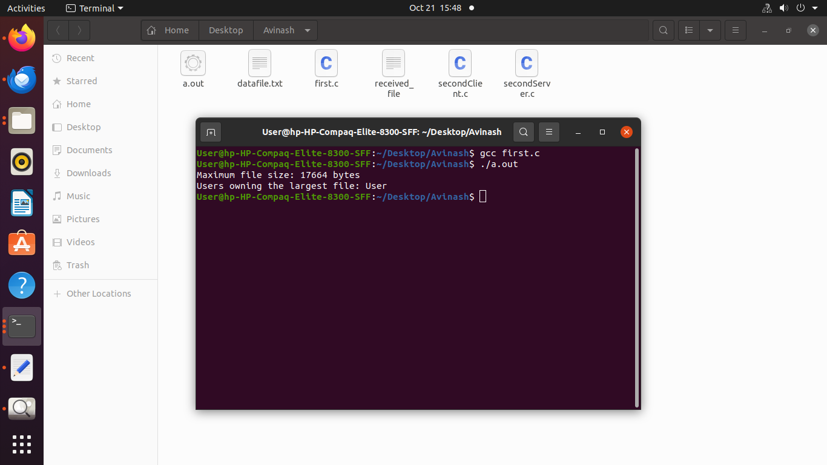

Question No – 02

**[Client]**

#include <stdio.h>

#include <stdlib.h>

#include <string.h>

#include <unistd.h>

#include <arpa/inet.h>

#define PORT 8080

#define BUFFER_SIZE 1024

void send_file(const char *filename, int socket) {

char buffer[BUFFER_SIZE];

FILE *fp;

size_t n;

// Open the file for reading

fp = fopen(filename, "rb");

if (fp == NULL) {

perror("File open error");

return;

}

// Send the file in chunks

while ((n = fread(buffer, sizeof(char), BUFFER_SIZE, fp)) > 0) {

if (send(socket, buffer, n, 0) < 0) {

perror("Send error");

break;

}

}

printf("File sent successfully.\n");

fclose(fp);

}

int main(int argc, char *argv[]) {

int sock;

struct sockaddr_in server_address;

if (argc < 2) {

fprintf(stderr, "Usage: %s <filename>\n", argv[0]);

return 1;

}

// Create socket

if ((sock = socket(AF_INET, SOCK_STREAM, 0)) < 0) {

perror("Socket creation error");

return -1;

}

server_address.sin_family = AF_INET;

server_address.sin_port = htons(PORT);

server_address.sin_addr.s_addr = inet_addr("127.0.0.1"); // Server IP

// Connect to the server

if (connect(sock, (struct sockaddr *)&server_address, sizeof(server_address)) < 0) {

perror("Connection error");

return -1;

}

send_file(argv[1], sock);

close(sock);

return 0;

}

**[Server]**

#include <stdio.h>

#include <stdlib.h>

#include <string.h>

#include <unistd.h>

#include <arpa/inet.h>

#define PORT 8080

#define BUFFER_SIZE 1024

void receive_file(int new_socket) {

char buffer[BUFFER_SIZE];

FILE *fp;

int n;

// Open the file for writing

fp = fopen("received_file", "wb");

if (fp == NULL) {

perror("File open error");

return;

}

// Receive the file in chunks

while ((n = recv(new_socket, buffer, BUFFER_SIZE, 0)) > 0) {

fwrite(buffer, sizeof(char), n, fp);

}

if (n < 0) {

perror("Receive error");

}

printf("File received successfully.\n");

fclose(fp);

}

int main() {

int server_fd, new_socket;

struct sockaddr_in address;

int opt = 1;

int addrlen = sizeof(address);

// Create socket file descriptor

if ((server_fd = socket(AF_INET, SOCK_STREAM, 0)) == 0) {

perror("Socket creation error");

exit(EXIT_FAILURE);

}

// Bind the socket to the port

if (setsockopt(server_fd, SOL_SOCKET, SO_REUSEADDR, &opt, sizeof(opt))) {

perror("Set socket options error");

exit(EXIT_FAILURE);

}

address.sin_family = AF_INET;

address.sin_addr.s_addr = INADDR_ANY;

address.sin_port = htons(PORT);

if (bind(server_fd, (struct sockaddr *)&address, sizeof(address)) < 0) {

perror("Bind error");

exit(EXIT_FAILURE);

}

// Listen for incoming connections

if (listen(server_fd, 3) < 0) {

perror("Listen error");

exit(EXIT_FAILURE);

}

printf("Server listening on port %d...\n", PORT);

// Accept an incoming connection

if ((new_socket = accept(server_fd, (struct sockaddr *)&address, (socklen_t*)&addrlen)) < 0) {

perror("Accept error");

exit(EXIT_FAILURE);

}

receive_file(new_socket);

close(new_socket);

close(server_fd);

return 0;

}

